Bilbao, febrero de 2020

Ontology documentation

Contents

**1.** **Ontological design** 2

**1.1.** Conceptual diagram of ontology ROH 3

**1.2.** Entity Project 4

**1.3.** Entity Person 6

**1.4.** Organization entity 9

**1.5.** Funding entity 11

**1.6.** Research Object Entity 13

**1.7.** Research Activity entity 14

**Bibliography** 17

# **Ontological design**

This section is going to break down from minor to major detail the design of the ROH ontology network. Starting in section 1 with a high level diagram, the most important entities will be shown. Then, the main entities modelled are broken down (sections **Error! Reference source not found.** to 1.7). Before, the following table shows a summary of the reused ontologies together with their respective user licenses. All reused ontologies have been evaluated for compatibility with their import and extension.

|  |  |  |  |
| --- | --- | --- | --- |
| prefix | Ontology names | License | Ontology website |
| bibo | Bibliographic Ontology | Creative Commons Attribution 1.0 Generic (CC BY 1.0) | <http://purl.org/ontology/bibo> |
| foaf | FOAF (Friend of a Friend) Vocabulary Specification | Creative Commons Attribution License 1.0 | <http://xmlns.com/foaf/0.1> |
| geonames | Geonames ontology | Creative Commons Attribution License 3.0 | [http://www.geonames.org/ontology#](http://www.geonames.org/ontology) |
| obo | Open Biological and Biomedical Ontology (OBO) | Creative Commons Attribution License 4.0 | <http://purl.obolibrary.org/obo/> |
| rdfs | RDF Schema | Creative Commons Attribution License 4.0 | [http://www.w3.org/2000/01/rdf-schema#](http://www.w3.org/2000/01/rdf-schema) |
| roh | Red de Ontologías Hercules | Creative Commons Attribution License 4.0 | <http://purl.org/roh> |
| skos | SKOS Simple Knowledge Organization System RDF Schema | Creative Commons Attribution License 4.0 | [http://www.w3.org/2004/02/skos/core#](http://www.w3.org/2004/02/skos/core) |
| vcard | vCard Ontology - for describing People and Organizations | Creative Commons Attribution License 4.0 | [https://www.w3.org/2006/vcard/ns#](https://www.w3.org/2006/vcard/ns) |
| vivo | VIVO Ontology for Researcher Discovery | Creative Commons Attribution License 4.0 | [http://vivoweb.org/ontology/core#](http://vivoweb.org/ontology/core) |

## Conceptual diagram of ontology ROH

Figura 1 shows the main entities modelled in the Hercules Ontology Network (HON in English, ROH-Red de Ontologías Hércules in Spanish). Note that in the diagram, the arrows with a filled tip denote kinship (inheritance) relationships while the arrows that end in a non-filled tip indicate that there is an Object Property relationship between these entities. Finally, the dashed arrows reflect the fact that several entities in ROH have geographic (class Geonames:Feature) and temporal (class vivo:DateTimeInterval) constraints.



**Figura 1**. High level diagram of ROH –Red de Ontologías Hércules.

## Entity Project

The main ROH entity is roh:Project (see Figura 2), a new entity defined within ROH. In ROH, a Project models a collaborative activity in business and science that often involves research or design, and is carefully planned to achieve a particular goal. Its configuration is inspired by the swrc:Project and takes into account the data properties of the cerif:Project. It comprises all those properties and adds some new ones, for example, roh:projectStatus or roh:title.

It includes the Data Properties vivo:identifier, roh:acronym, vivo:description, roh:title, roh:projectStatus and vivo:keywords.

An roh:Project includes several sub-classes roh:PrivateProject and roh:PublicFundingProject. The first subclass includes the subclasses roh:Agreement whilst the latter one defines as its subclasses: roh:Bidding, roh:EuropeanProject, roh:NationalProject or roh:RegionalProject.

Besides, an instance of a roh:Project is associated to the following entities through object properties:

* foaf:Organización, where different organizations may play different obo:Roles in a project, e.g. vivo:MemberRole or vivo:AdministratorRole.
* foaf:Person, where an person may play different obo:Roles, e.g. vivo:PrincipalInvestigatorRole or vivo:ResearcherRole,
* roh:ResearchObject, where a project roh:produces several roh:ResearchObject, where some results of a project might be for example of types bibo:Journal, obo:JournalArticle, or roh:PhDThesis.
* roh:FundingOrganization sponsors (roh:funds) a roh:Funding. A funding roh:hasPart roh:FundingAmount. A roh:FundingAmount roh:grants foaf:Organization it describes the details about the funding associated to a project. A roh:Funding roh:supports a roh:Project.
* roh:Expense is roh:spentBy a project, details allows to associate a project with its expenses.
* roh:Activity is roh:participatedBy a project, describes what activities a project participates in.
* skos:Concept is linked through roh:knowledgeAreaOf to a project, indicating the topics/concepts a project deals with.
* roh:ProjectContract subtype of vivo:Contract, a project may be associated to a contract through relationship roh:hasContract.
* roh:Justification through relationship vivo:relates binds justifications with a roh:Project.
* roh:File through relationship vivo:relates binds administrative file with a roh:Project. An administrative file a collection in which all assets related to a Project are stored, including the Research Proposal, approval documents, viability plans and so on associated to a project are stored.

Notice that a roh:Project may also be part (vivo:hasPart) of another project, e.g. child of a parent project. Besides, every instance of a roh:Project is time bound by being associated with an instance of vivo:DateTimeInterval and geographically bound to an instance of gn:Feature (through relationship (gn:locatedIn).

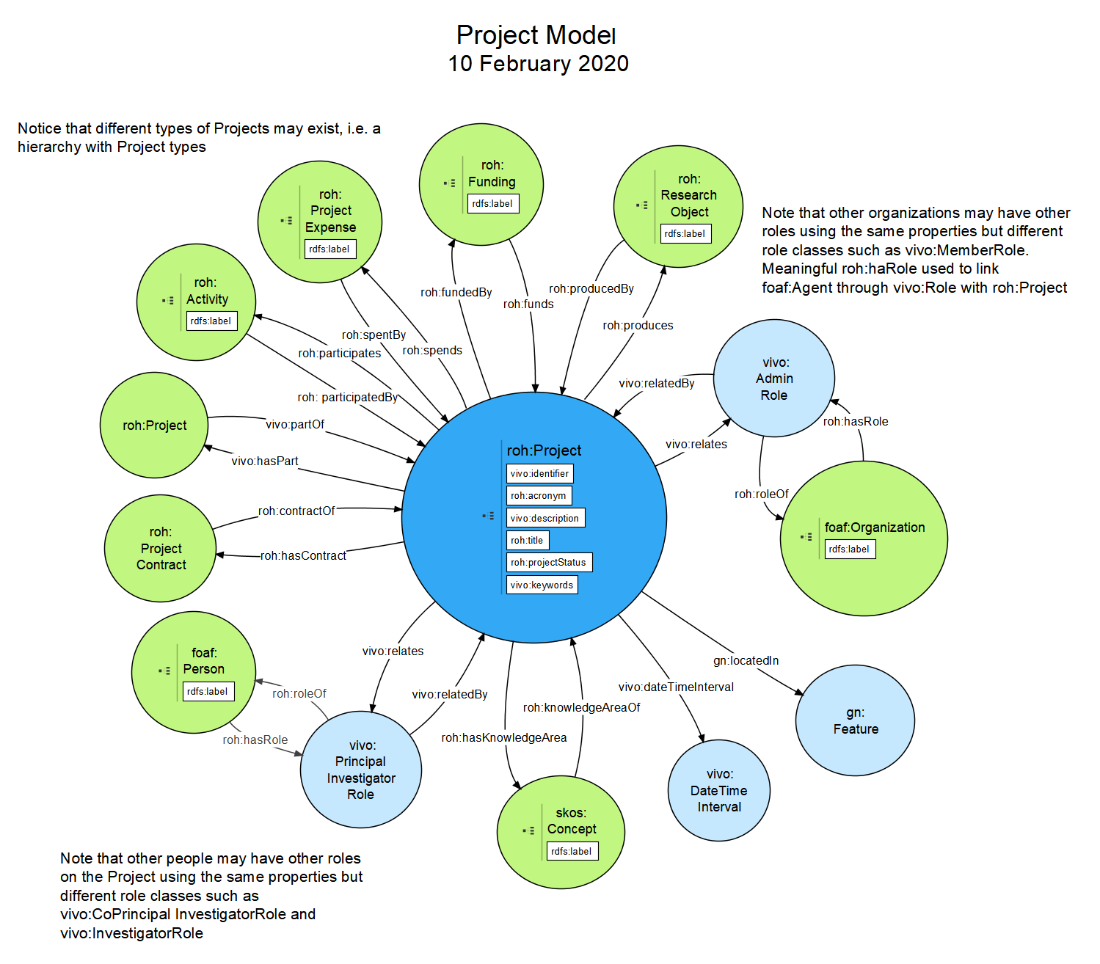

**Figura 2**. Ontological diagram for entity Project.

## Entity Person

In ROH, there is a foaf:Person entity (see Figura 3) that inherits from foaf:Agent. However, the main entity that users of ROH will deal with is roh:Researcher. Such entity inherits from foaf:Person.

The specialization of this entity imported from the VIVO ontology already adds some DataType properties of the research domain, but in ROH we also incorporate roh:taxID or roh:ORCID and also several object specific properties of the research domain as "has a Role" (roh: hasRole) in an Organization, "has a CurriculumVitae" (roh:hasCV), "has some Accreditations" (roh:hasAccreditation), "has an Employment Contract" (roh:hasContract), "has some Knowledge Areas" (roh:hasKnowledgeArea) or "has some Roles" (roh:hasRole) in Projects or participates through "bibo:authorList" with Research Objects of subclass bibo:Document. A person can "have different roles" in the Project over time.

As mentioned above, foaf:Person in ROH is based on FOAF (Friend of a Friend [2], following patterns used in VIVO. That explains why it includes some of the basic FOAF properties such as foaf:name, foaf:nick, foaf:title, foaf:mbox (note that this in fact an object property), foaf:img (note that this in fact an object property), vivo:description, foaf:firstName and foaf:surname. However, it considers all attributes and links defined in CERIF through the cfPers entity. foaf:Person incorporates the following data properties declared as attributes in cfPers, especially: identifier (vivo:identifier but preferrably roh:ORCID), roh:birthdate, foaf:gender, foaf:homepage (note that this in fact an object property), roh:researchLine, vivo:keywords. Some important CERIF relationships that have also been adopted: Curriculum Vitae (roh:hasCV) which links foaf:Person with roh:CurriculumVitae, Event (roh:Activity) and Indicator (roh:Accreditation).

A taxonomy of types of persons has been imported in the research field from VIVO [1], such as vivo:FacultyMember, vivo:Librarian, vivo:NonAcademic, vivo:PostDoc or vivo:GraduateStudent or some additional one by ROH as, the very important subclass roh:Researcher.

Besides, an instance of a foaf:Person / roh:Researcher is associated to the following entities through object properties:

* roh:Accreditation, where a researcher roh:hasAccreditation of different types, e.g. roh:ResearchAccreditation or roh:AcademicAccreditation.
* roh:Activity, where a researcher roh:participates in diverse activities, e.g. vivo:InvitedTalk or bibo:Conference.
* vivo:AwardedDegree, where a researcher vivo:relates with an roh:AcademicDegree
* roh:CorrespondingAuthor, where a researcher is the roh:correspondingAuthor of different subtypes of roh:ResearchObject, e.g. obo:JournalArticle, vivo:ConferencePaper or bibo:Proceedings.
* roh:CurriculumVitae, where a researcher roh:hasCV which includes data type properties like roh:cites, roh:factorH or roh:summary
* bibo:Document, where a researcher through bibo:authorList is participating in a bibo:Document as one of its authors.
* vcard:Individual, where a researcher obo:hasContactInfo described through ontology vcard.
* vivo:Position, where a researcher roh:hasPosition usually in an organization linking it to any of the vivo:Position subclasess like vivo:FacultyAdministrativePosition or vivo:FacultyPosition.
* roh:Role, where a foaf:Agent, i.e. and its subclasses like foaf:Person or roh:Researcher, roh:hasRole like vivo:ResearcherRole or vivo:TeacherRole either in a roh:Project or a foaf:Organization.
* roh:PersonContract, where a researcher roh:hasContract described according to the attributes corresponding to parent class vivo:Contract.
* bibo:Thesis, where a researcher is roh:supervisor of a bibo:Thesis, concretely, any of its subtypes subclasess like roh:MasterThesis or roh:PhDThesis.

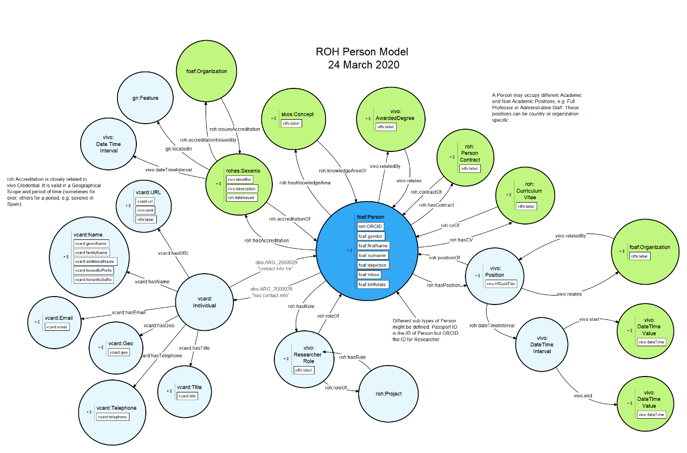

**Figura 3**. Ontological Diagram for entity Person.

## Organization entity

An Organization in ROH (see Figura 4) is a foaf:Organization which carries out several roh:Project. It is a child of foaf:Agent. Some organization can emit roh:Acreditation (e.g. ANECA or CENAI in Spain), those belonging to subclass roh:AccreditationIssuer, or award degrees (vivo:AwardedDegree), those of subclass vivo:University. An Organization may receive several roh:FundingAmount, corresponding to a roh:Funding, obtained through a roh:FundingProgram provided by a vivo:FundingOrganization through a roh:FundingSource. As a foaf:Agent an Organization may be involved in several roh:Actitity, has several instances of attribute roh:researchLine, is associated through roh:hasKnowledgeArea with roh:KnowledgeArea and bound to a geographical scope through gn:locatedIn with gn:Feature, it may also have a time span through vivo:dateTimeInterval linking it with an instance of vivo:DateTimeInterval.

Based on FOAF [10], the foaf:Organization entity takes into account the object properties (attributes: roh:acronym, foaf:homepage) and data properties (links) defined by the Organization Unit in CERIF. It also takes into account and supports the relationships of CERIF Equipment (via roh:Equipment and roh:hasInfrastructure), Event (roh:Activity), Expertise and Skill (via vivo:keywords and roh:hasKnowledgeArea), Facility (roh:Facility and roh:hasInfrastructure), Funding (roh:Funding), Organization Unit (kinship relationships between organizations can be established with vivo:hasPart and vivo:partOf), Prize Award (through roh:Accreditation), Result Patent, Result Product, Result Publication and Service - all of them through roh:ResearchObject which can be obtained through the roh:produces relationship from the Projects in which an organization participates by playing a declared role through roh:hasRole, Person (through roh:hasPosition). Therefore, the CERIF data model for Organization is covered.

An exhaustive hierarchy of organizations is includes, e.g. roh:AccreditationIssuer, vivo:Company or vivo:University, among many others.

Besides, an instance of a foaf:Organization is associated to the following entities through object properties:

* roh:Accreditation, where an organization of type roh:AccrediationIssuer issues (roh:issues) accreditations, e.g. roh:ResearchAccreditation or roh:AcademicAccreditation.
* roh:Activity, where an organization may play vivo:OrganizerRole through roh:hasRole in an activity or may through its participation role in a project participate (roh:participates) in an activity.
* vivo:AwardedDegree, where and organization may roh:awards degrees which are related to both a concrete vivo:AcademicDegree and an instance of foaf:Person.
* skos:Concept, where an organization through roh:hasKnowledgeArea may be associated to several knowledge areas, defined as instance data of thesaurus created with SKOS ontology.
* vivo:DateTimeInterval, where an organization may exist during a given time interval
* gn:Feature through relationship gn:locatedIn, where an organization may be associated a geographical scope.
* roh:FundingAmount where an organization may receive several funding amounts part of a roh:Funding through roh:grants object property.
* vcard:Individual, where an organization obo:hasContactInfo described through ontology vcard.
* roh:Infrastructure, where an organization may roh:hasInfrastructure, belonging to any of its subclasses, e.g. roh:Equipment or roh:Facility.
* foaf:Organization, where a foaf:Organization may be linked through vivo:hasSucessorOrganization or vivo:hasPredecessorOrganization with another foaf:Organization or may be part of (vivo:partOf) or include (vivo:hasPart) other several foaf:Organization.

**Figura 4**. Ontological diagram for entity Organization.

## Funding entity

The roh:Funding entity (see Figura 5), new in ROH, represents the funding associated with a project (roh:Project) whose funding is associated with a funding program (roh:FundingProgram) and comes from a (roh:FundingSource), which in turn is associated with a funding organization (vivo:FundingOrganization). A funding is divided into several amounts (roh:FundingAmount), associated with the different entities that participate in a project and the annuities in which they do so. Funding gathers information about the total funding received for a project and its currency through the roh:monetaryAmount and roh:currency properties.

The funding organization (vivo:FundingOrganization) (see Figura 5), imported from VIVO [1], inherits from foaf:Organization, finances (roh:funds) through different funding aids (roh:Funding) to projects (roh:Project) through the roh:supports relationship and through the roh:FundingAmounts into which a roh:Funding is divided. A funding organization in turn divides a roh:Funding into several roh:FundingAmounts associated with different foaf:Organizations through the roh:grants relationship.

The Funding Program entity (roh:FundingProgram) (see Figura 5), new in ROH, defines the funding initiatives promoted (roh:promotedBy) by a Funding Organization (vivo:FundingOrganization) and is in operation during a time interval (vivo:dateTimeInterval) and is usually linked to a geographical scope (geonames:Feature).

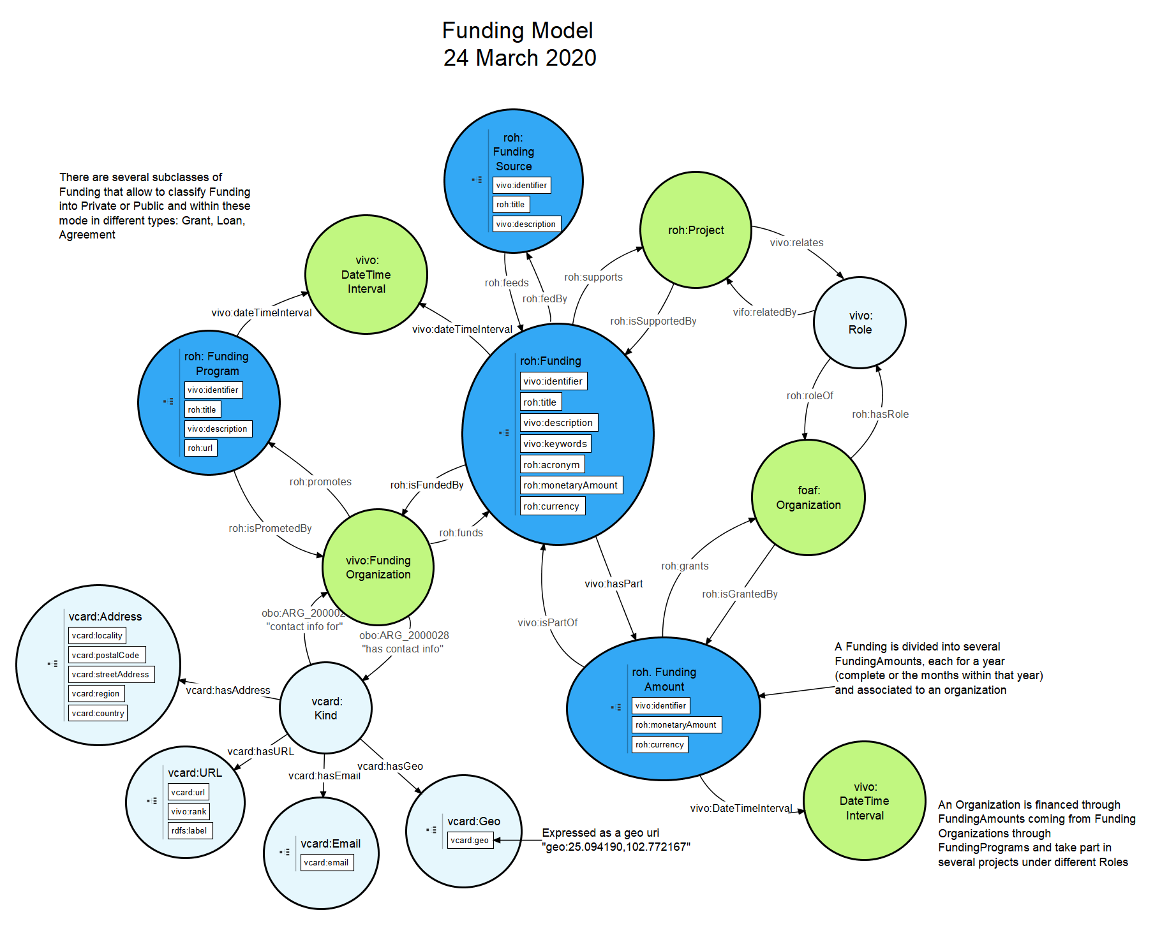

**Figura 5**. Ontological diagram for Funding.

## Research Object Entity

The research object entity (roh:ResearchObject) is a new entity defined in ROH (see Figura 6) that corresponds to a research result generated by a person (researcher), usually through work on a project. A roh:ResearchObject is associated with several foaf:Person through the bibo:authorList property. Usually a roh:ResearchObject results from working on a roh:Project (roh:produces). This entity defines a complete taxonomy of research objects mostly imported from BIBO [4], covering all kinds of publications, patents, software and web pages. Some examples are: bibo:Collection, bibo:Journal, bibo:Article, bibo:Book, bibo:Chapter, bibo:Patent, bibo:Thesis and bibo:Webpage. The primary author of a research object is accessible through the roh:correspondingAuthor property.

The most important research result is represented by the concept publication and is defined mainly through the imported entity vivo:Document. Currently, the following sets of entities related to the publication concept are supported: bibo:Collection (Newspaper, Magazine) and bibo:Document (Article, ConferencePaper, EditorialArticle, Book, Proceedings, ConferencePaper, Chapter, Thesis) and obo:Software. bibo:Thesis has been refined into roh:DegreeThesis, roh:MasterThesis and roh:PhDThesis.

**Figura 6**. Ontological diagram for ResearchObject.

## Activity entity

The entity research activity (roh:Activity), new in ROH and visualized in Figura 7, represents the activities in which People participate (roh:participes) and organized by Organizations (foaf:Organization) reflected through the roh:hasRole relationship that connects with the intermediary entity vivo:OrganizerRole. Each activity is usually linked to a project through the relationship (roh:participes) and causes a project expenditure linked through (vivo:relates). A detailed hierarchy of activity subtypes is defined as roh:Activity: bibo:Conference, vivo:Internship or roh:ThesisViva.

Related to Activity, it is also important to describe roh:Expense, which denotes the expenses incurred either by a project (roh:Project) or person (foaf:Person) and linked through roh:spends. Every expense has a time instant of associated expense (vivo:DateTimeValue) and other properties that qualify it as (roh:monetaryAmount, roh:currency, roh:title or vivo:description. It should be extended with more types of expenses, such as personnel costs, subcontracting, travel, equipment, research infrastructure and other goods and services. Currently, a distinction is made between roh:PersonExpense and roh:ProjectExpense.

**Figura 7**. Ontological diagram for entity Activity.

# **Bibliography**

[1] «Ontology Reference - VIVO 1.10.x Documentation - LYRASIS Wiki». [En línea]. Disponible en: https://wiki.lyrasis.org/display/VIVODOC110x/Ontology+Reference. [Accedido: 12-feb-2020].

[2] «Current research information system - Wikipedia». [En línea]. Disponible en: https://en.wikipedia.org/wiki/Current_research_information_system. [Accedido: 14-feb-2020].

[3] «CERIF 1.5 Reference». [En línea]. Disponible en: https://www.eurocris.org/Uploads/Web%20pages/CERIF-1.5/cerif.html#cfResProd. [Accedido: 13-feb-2020].

[4] «euroCRIS | Current Research Information Systems». [En línea]. Disponible en: https://www.eurocris.org/. [Accedido: 14-feb-2020].

[5] «SKOS Simple Knowledge Organization System Namespace Document 30 July 2008 “Last Call” Edition». [En línea]. Disponible en: https://www.w3.org/TR/2008/WD-skos-reference-20080829/skos.html. [Accedido: 13-feb-2020].

[6] «Public Procurement Ontology». [En línea]. Disponible en: http://contsem.unizar.es/def/sector-publico/pproc.html. [Accedido: 13-feb-2020].

[7] «CVN». [En línea]. Disponible en: https://cvn.fecyt.es/editor/cvn.html?locale=spa#ENTRADA. [Accedido: 13-feb-2020].

[8] «SWRC-FE (SWRC Funding Extension) | MORElab Ontologies». [En línea]. Disponible en: https://morelab.deusto.es/ontologies/swrcfe. [Accedido: 13-feb-2020].

[9] «GeoNames Ontology - Geo Semantic Web». [En línea]. Disponible en: http://www.geonames.org/ontology/documentation.html. [Accedido: 13-feb-2020].

[10] «FOAF Vocabulary Specification». [En línea]. Disponible en: http://xmlns.com/foaf/spec/. [Accedido: 12-feb-2020].

[11] «Bibliographic Ontology Specification | The Bibliographic Ontology». [En línea]. Disponible en: http://bibliontology.com/. [Accedido: 13-feb-2020].

[12] «OOPS! – OntOlogy Pitfall Scanner!» [En línea]. Disponible en: http://mayor2.dia.fi.upm.es/oeg-upm/index.php/en/technologies/292-oops/index.html. [Accedido: 13-feb-2020].